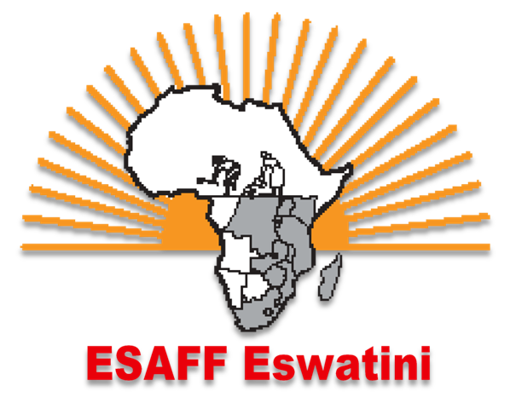

CONTACTS

Office: Cell +268 7829 5120/+268 76310775
P.O. Box C2736 Manzini, Inside SWAFCO Building, Mancishane Street,
Email: esaffswaziland@gmail.com

Maswati Dludlu
(Coordinator)
Cell: +268 7670 5343
coordinator@esaffeswatini.org

Website: www.esaffeswatini.org

DR DAN DLAMINI’S PERSPECTIVE ON

2018-2019 NATIONAL BUDGET
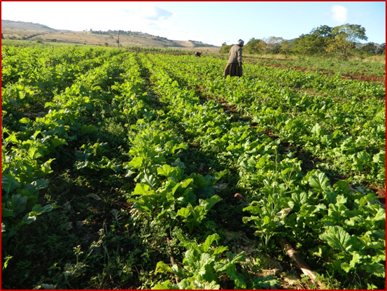
ESAFF Swaziland in conjunction with the Swaziland Economic Justice Network (SEJUN) hosted Dr Dan Dlamini, a lecturer at the University of Swaziland who helped to unpack the National Budget of 2018-2019.
The doctor said any budget was about the allocation of resources and distribution of income and wealth and therefore required the participation of all sectors. He stated that in the budget, government set out what it was going to spend (expenditure) and the income it collected (revenue), which it needed to finance expenditure, and while at it government had to balance a wide range of legitimate demands with limited resources at its disposal.
He said whilst the budget had to be influenced by the National Development Plan and the ‘Speech from the Throne’ during the official opening of Parliament each year, Members of Parliament were expected to consult their constituencies on how the budget should look like. He said the budget must be realistic and show income and expenditure, priotirise spending by government on the nation and that it must been seen to contribute and strengthen democracy, emphasising that there was no way humanity could be removed from politics. Budget support is intended to help government move forward to realise its goals by increasing governments’ accountability to citizens.
Dr Dlamini said budgetary work was one of the most important oversight functions of Parliament, adding that the budget reflected the choices that government had to make, and was the tool it used to achieve its economic and development goals.
He noted that most people lived by the countryside and sustained their livelihoods through agricultural activities, which had to be reflected in the budget.
Participants then noted that the National Budget lacked people’s participation, did not prioritise key issues but funded vanity projects and desires of the ruling elite. Therefore, they called for a ‘PEOPLE’S BUDGET’ where communities are allowed to submit and influence allocations and identify priority areas for funding, particularly farming.
BELOW IS THE DOCTOR’S PERSPECTIVE IN GENERAL
It is important to measure the effectiveness of public spending and the manner in which public resources are spent.
The more immediate goals of applied budget work are to ensure that government budget priorities are consistent with declared policy objectives, and that the financial resources allocated to priority areas are expended fully and properly.
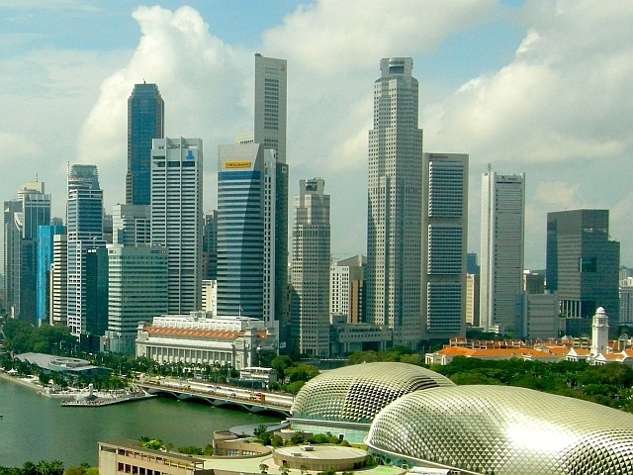
However, budget work also has a larger purpose, which is to contribute to democracy through ensuring openness, transparency and accountability for public resources.
In its strictest, most technical sense, a budget is a document containing words and figures that propose expenditures for certain items and purposes.
While considerations of revenue constraints and taxation are inherent in the budget process, within the context of parliamentary work, budgeting is generally treated as part of the expenditure process, rather than as a revenue raising process.
In this respect, public budgeting serves as the allocation of expenditures among different purposes so as to achieve the greatest results.
A budget can be viewed from various frames of reference.
Political process:
The allocation of the budget is a key instrument for government to promote economic development efficiently. The budget allocation process is a political issue, and understanding the institutional and political context in which budget decisions are made and implemented is critical for achieving better outcomes.
Economic process - resource allocation:
The budget is the most important economic instrument of the government, as it reflects the country’s socio-economic policy priorities by translating priorities and political commitments into expenditures. In this way, the budget emphasises constraints and trade-offs in policy choices.
Administrative process - planning, coordinating, control and evaluation Administratively, the budget serves as a financial plan that serves as the pattern for and control over future operations, as well as a systematic plan for the utilisation of person power, material or other resources. It brings together estimates of anticipated revenues and proposed expenditures, outlining the schedule of activities to be undertaken and the means of financing those activities. In the budget, fiscal policies are coordinated, and only in the budget can a more unified view of the financial direction of the State be observed.
Human rights process - allocation of funds in compliance with state obligations towards the full realisation of constitutional rights.
From a human rights framework, a national budget can be defined as a process through which financial resources are allocated in compliance with State obligations to respect, protect and fulfil human rights. The status of human rights and compliance with State obligations become the key determinants of the choices made relative to financial resource allocation. A State’s human rights obligations should guide the ultimate purpose of government: to use all tools at its disposal to ensure the guarantee and enjoyment of all human rights by all individuals. Thus, State obligations provide the priorities underlying the economic and administrative decisions reflected in the national budget
FUNCTIONS OF THE BUDGET
Three central economic functions of the government budget are:
Allocation of resources: This function relates to the provision of public goods and services by the government. All the goods and services in a
Distribution of income and wealth: Budgetary policy can be used to attempt to redress inequalities in income and wealth distribution. Budgets are premised on the assumption that a ‘fair’ and equitable distribution between all groups of society is an important goal.
Stabilisation of the economy: Government budgets are used to promote a certain level of employment, stability in prices, economic growth, environmental sustainability and external balance.
Stabilisation policy requires economic, political, and social judgements in determining, for example, which objective has priority at any one time, as well as what the acceptable levels of unemployment, debt, and interest rates are, and so forth
BUDGET PRINCIPLES
The budget should be governed by several principles, including transparency, accountability, participation, equity, non-discrimination and equality.
Transparency:
The principle of transparency is important in the budget process, as it allows for informed analysis of government policies and facilitates the identification of weaknesses, leading to the implementation of needed reforms. Transparency can increase faith in the government, and can contribute to consensus building and The principle of transparency is therefore crucial to the budget process, mandating that information affecting budget decisions (budgetary and fiscal information, information on development thrusts and programmes, etc.) should be accurate, true and portray the genuine state of the economy. In addition, this information should be made available and accessible to the general public, open to public scrutiny, and written clearly so as to be readily understood by the public.
Participation:
Participation in all levels of social, political and economic decision-making is both a right and a duty of all individuals. Involved participation is affirmative in the sense that it explicitly includes input from all sectors of society, and is likely to result in more equitable expenditure patterns than a process which is dominated by the powerful sectors of society.
Stakeholders who can be consulted include citizens, lobbyists, professionals, specialists, engineers (in the case of infrastructure projects) and analysts.
Accountability:
The principle of Accountability is important in the budget process. Public funds are derived mainly from two sources: contributions of citizens through taxation, and public borrowings whose burden of repayment is borne by taxpayers. Thus the State should be held responsible and accountable for how it raises public funds and how it spends taxpayers’ money.
Equity and Equality:
The budget should be governed by the principles of equity, equality and non-discrimination. Public allocations should be fair and just, and should be available to all citizens equally, without discrimination based on gender, ethnicity, social class, age, etc.

YEAR | EXPENDITURE/BUDGET | TOTAL VEVENUE | SURPLUS/DEFICIT
2018/2019 | E21.6 BILLION | E17.26 BILLION | E4.3 BILION (DEFICIT)
2017/2019 | E21.8 BILLION | E16.9 BILLION | E4.9 BILLION 9DEFICIT)
2016/2017 | E20.7 BILLION | E14.17 BILLION | E6.5 BILLION (DEFICIT)
2015/2016 | E15.9 BILLION | E14.6 BILLION | E1.3 BILLION (DEFICIT)
2014/2015 | E15.3 BILLION | E14.25 BILLION | E1 BILLION (DEFICIT)
2013/2014 | E12.6 BILLION | E12.8 BILLION | E397 MILLION (DEFICIT)
2012/2013 | E11.5 BILLION | E12.2 BILLION | E200 MILLION (SURPLUS)
2011/2012 | E10.7 BILLION | E8.5 BILLION | E2.2 BILLION (DEFICIT)
2010/2011 | E10.4 BILLION | E7.1 BILLION | E3.3 BILLION (DEFICIT)
2009,2010 | E11.4 BILLION | E9.4 BILLION | E1.9 BILLION (DEFICIT)

KEY MINISTRIES/DEPARTMENTS BUDGET 2017/2018
EDUCATION | E3.3 B | E3.5 B | -E2 M
HEALTH | E1.9 B | E2.2 B | -E3 M
AGRICULTURE | E1.4 B | E741 M | E659 M
DEFENCE | E1.1 B | E1.2 B | -E1 M
POLICE | E1 B | E995.7 M | E4.3 M
CORRECTIONAL | E490.7 M | E505 M | -E15 M

